The Mixed Nuts
Set JJ Last revised on 2018.09.01
JJ01-This Could Be The Start Of Something Big(KVD).2018.05.24.pdf
JJ01-This Could Be The Start Of Something Big(VOCAL DUET).2018.09.01.pdf
JJ02-Blue Skirt Waltz(KV).2015.04.24.pdf
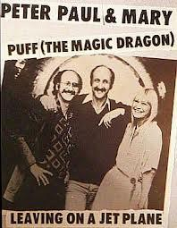
JJ03-Kiss Of Fire(KVF)2016.02.15.pdf
JJ03-Kiss Of Fire(KVM)2016.02.15.pdf
JJ04-Sweet Sue - Just You(KV).2013.09.13.pdf
JJ05-Little Things Mean A Lot(KVF).2018.09.01.pdf
JJ05-Little Things Mean A Lot(KVM).2018.09.01.pdf
JJ06-Too Fat Polka(KV).pdf
JJ07-Stranger On The Shore(KVF).2018.01.31.pdf
JJ07-Stranger On The Shore(KVF).2018.09.01.pdf
JJ07-Stranger On The Shore(KVM).2018.09.01.pdf
JJ08-There'll Be Some Changes Made(KVM).2016.03.21.pdf
JJ09-Puff, The Magic Dragon(KV).2018.06.26.pdf
JJ10-Leavin' On A Jet Plane(KVF).2018.06.26.pdf
JJ10-Leavin' On A Jet Plane(KVM).2018.06.26.pdf
JJ11-Blowin' In The Wind(KVD).2016.03.21.pdf
JJ12-I'll See You In My Dreams(KVF).2016.03.21.pdf
JJ12-I'll See You In My Dreams(KVM).2016.03.21.pdf
JJ13-Tonight You Belong To Me(KVD)(Female Lead).2018.03.15.pdf
JJ13-Tonight You Belong To Me(KVD)(Male Lead).2018.03.15.pdf
JJ14-We're In The Money(KVF).pdf
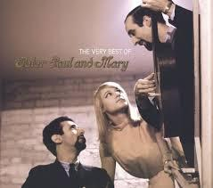
JJ14-We're In The Money(KVM).pdf
JJ15-When The Moon Comes Over The Mountain(KVF).pdf
JJ15-When The Moon Comes Over The Mountain(KVM).pdf
JJ16-Arrevederci, Roma(KVF).2018.06.26.pdf
JJ16-Arrevederci, Roma(KVM).2018.06.26.pdf
JJ17-Hucklebuck, The(KVM).2018.09.01.pdf
JJ17-Hucklebuck, The(KVF).2018.09.01.pdf

